Clinical Trial Patient Matching System (CTPMS)



Project Sponsor: Prof. David Pitts
Instructor, COMP-699-A Professional Seminar
Rivier University - Nashua, NH

Submitted By: Likitha Chowdary Chereddy
Student ID: 0104363
Spring 2026_ Rivier University

INTRODUCTION

The Clinical Trial Patient Matching System (CTPMS) is designed to improve the efficiency, consistency, and scalability of patient-to-clinical-trial eligibility evaluation through a structured, rule-based decision-support architecture. Traditional recruitment workflows require research coordinators to manually interpret complex inclusion and exclusion criteria across multiple trials, often leading to inconsistent evaluations and delayed enrollment timelines. CTPMS addresses this challenge by formalizing eligibility logic into evaluable rule sets and integrating patient data management, trial configuration, and screening workflows within a unified system. By transforming narrative protocol criteria into structured logic, the system reduces subjectivity while enabling systematic and repeatable eligibility assessment.
The structural and behavioral models presented in this document translate previously defined functional requirements into a formal architectural representation of the system. Structural models describe the static organization of core domain entities—such as Patient, Clinical Trial, Eligibility Rule, MatchSession, and User roles—and define their relationships using object-oriented design principles. These models establish the internal data architecture necessary to support secure patient data handling, rule processing, and role-based access control. Behavioral models complement this perspective by illustrating the dynamic interactions between system components during execution. Sequence diagrams demonstrate how objects collaborate to perform key operations, including automated matching, weighted scoring, eligibility explanation generation, screening workflow management, and administrative control.
Together, these models ensure traceability from functional requirements (FR-1 through FR-40) to internal system design while enforcing separation of concerns and modularity. By adopting a use-case driven and iterative refinement approach, the system design moves beyond conceptual requirements toward a structured, implementable architecture aligned with object-oriented development in Python. The resulting models provide a comprehensive foundation for prototype implementation and validation, consistent with graduate-level standards in systems analysis and design.

USECASE DIAGRAM
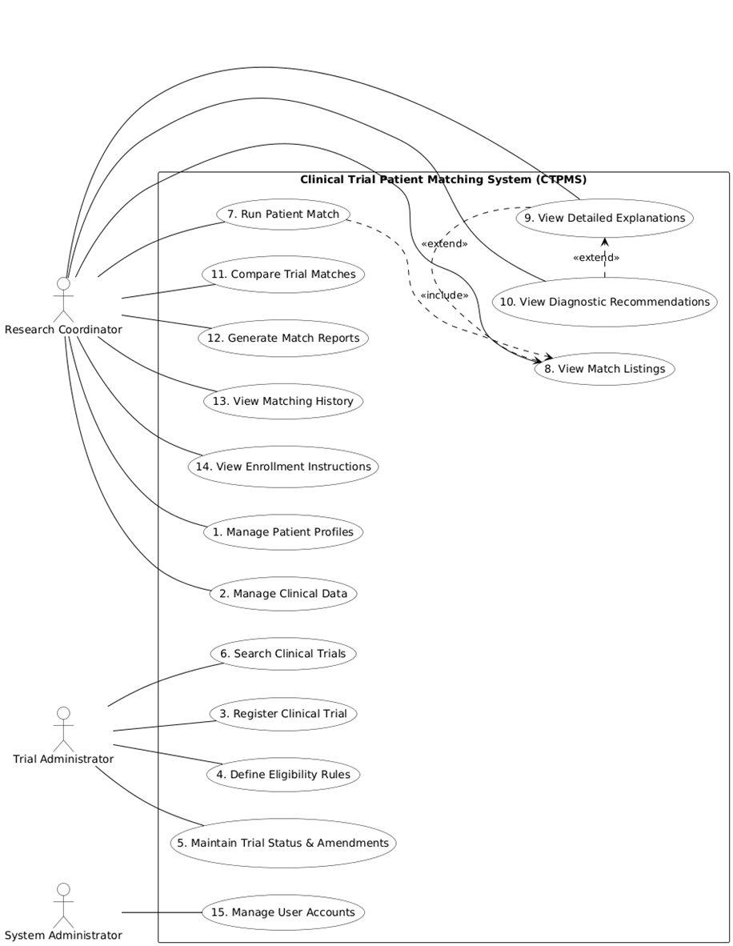

CLASS DIAGRAM

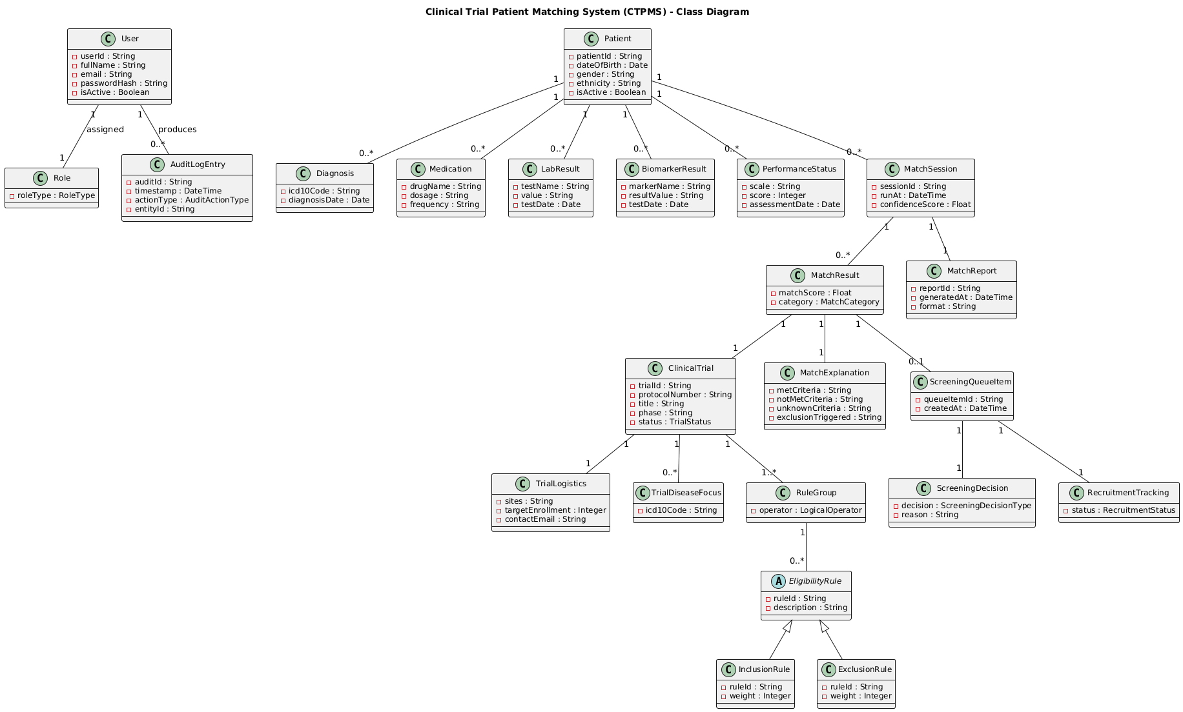

OBJECT DIAGRAM
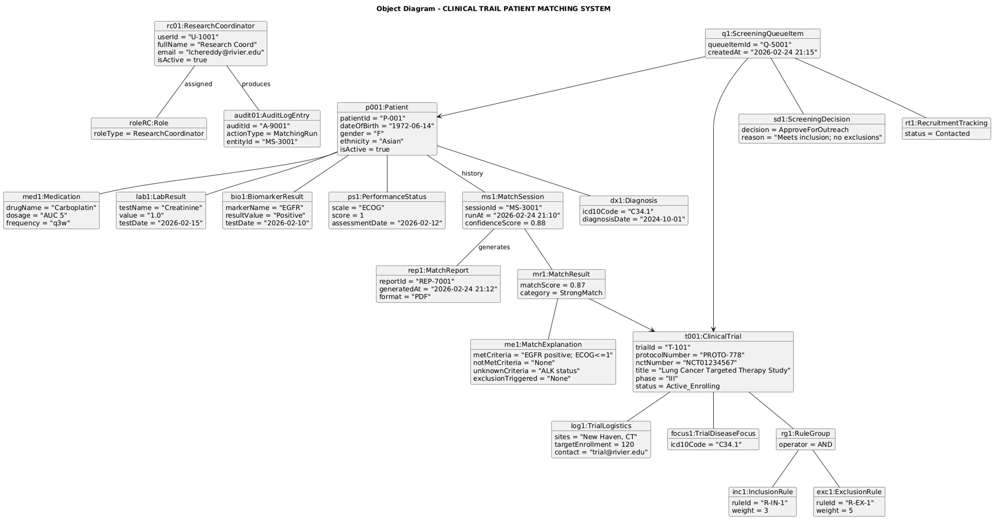

SEQUENCE DIAGRAMS

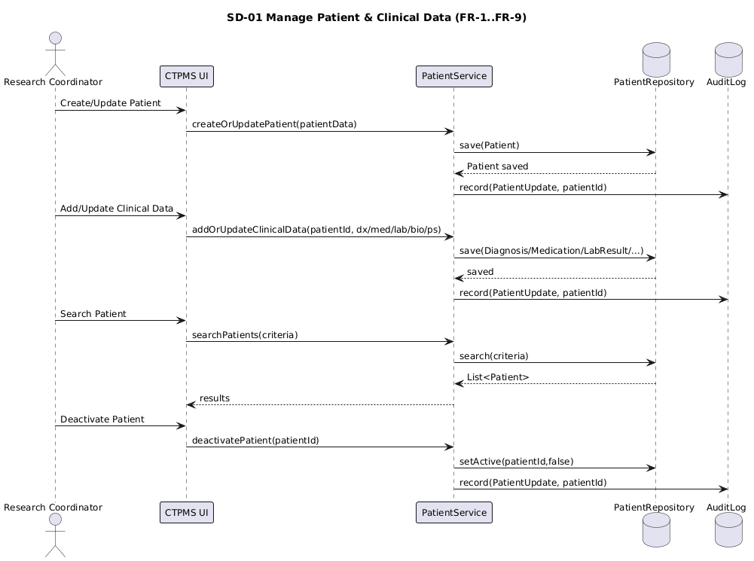
- Manage Patient & Clinical Data

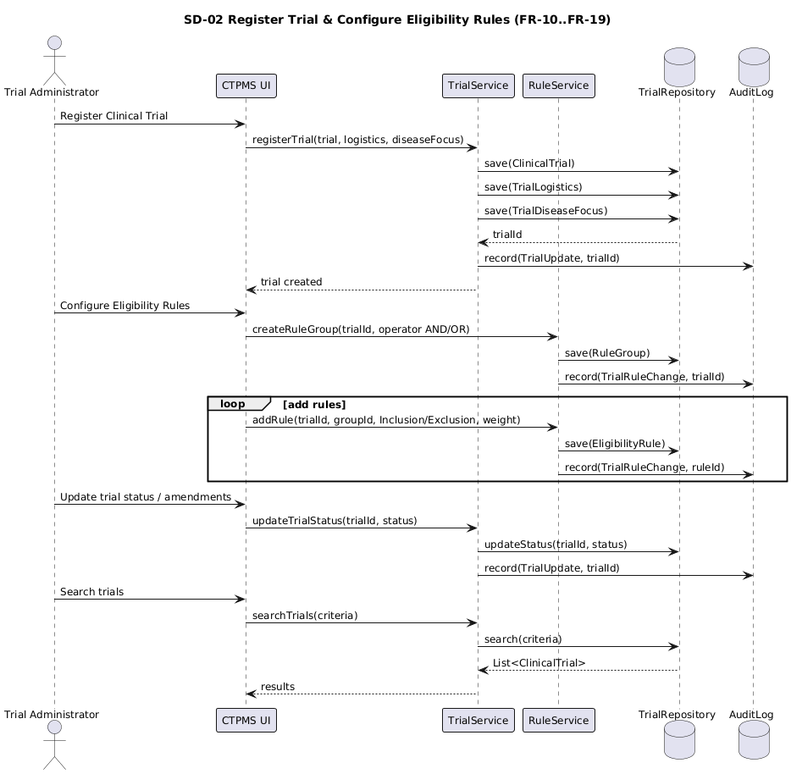
- Register Trial & Configure Eligibility Rules

- Run Match, Rank Results, Categorize
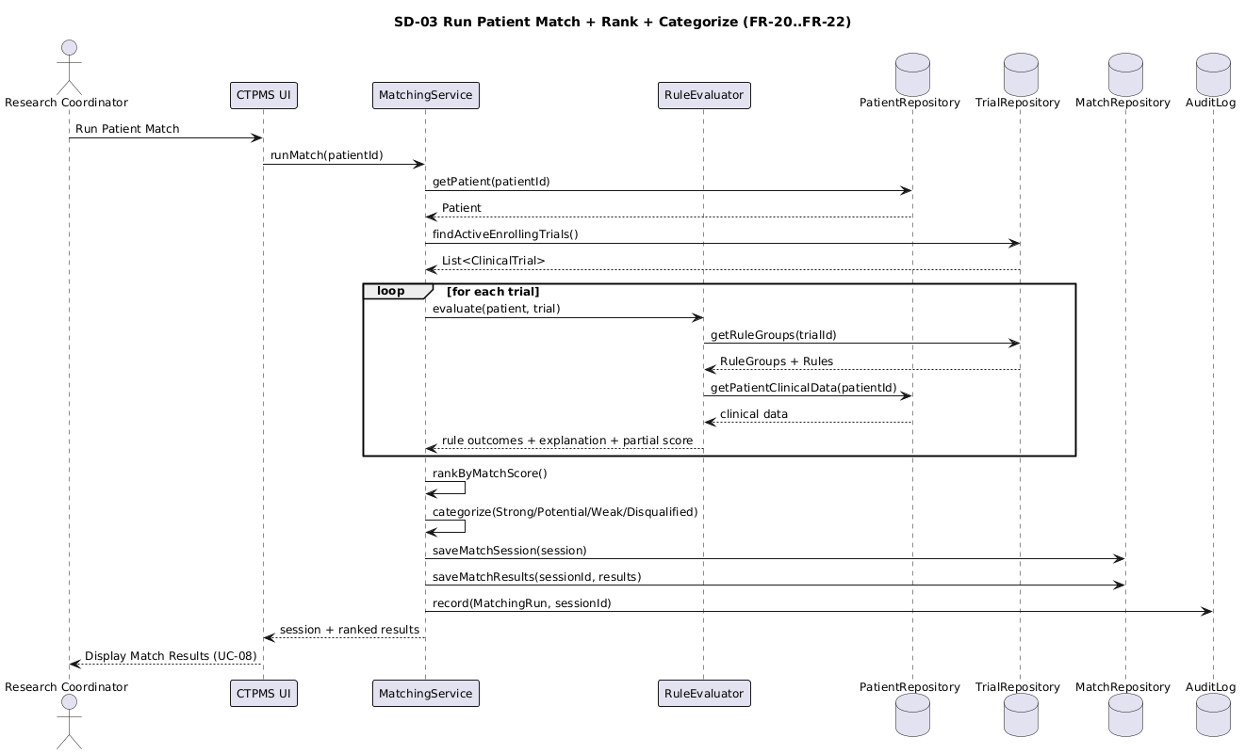

- View Explanation, Recommendations, Compare Trails
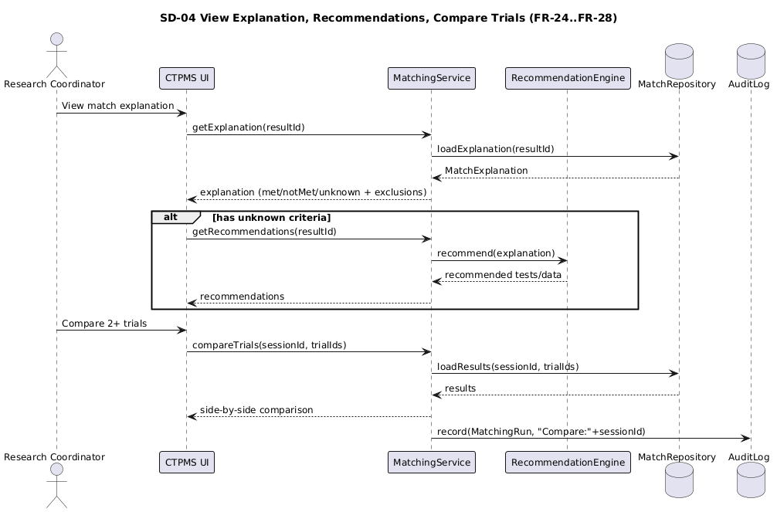

- Generate Match Report, View History, Enrollment Info

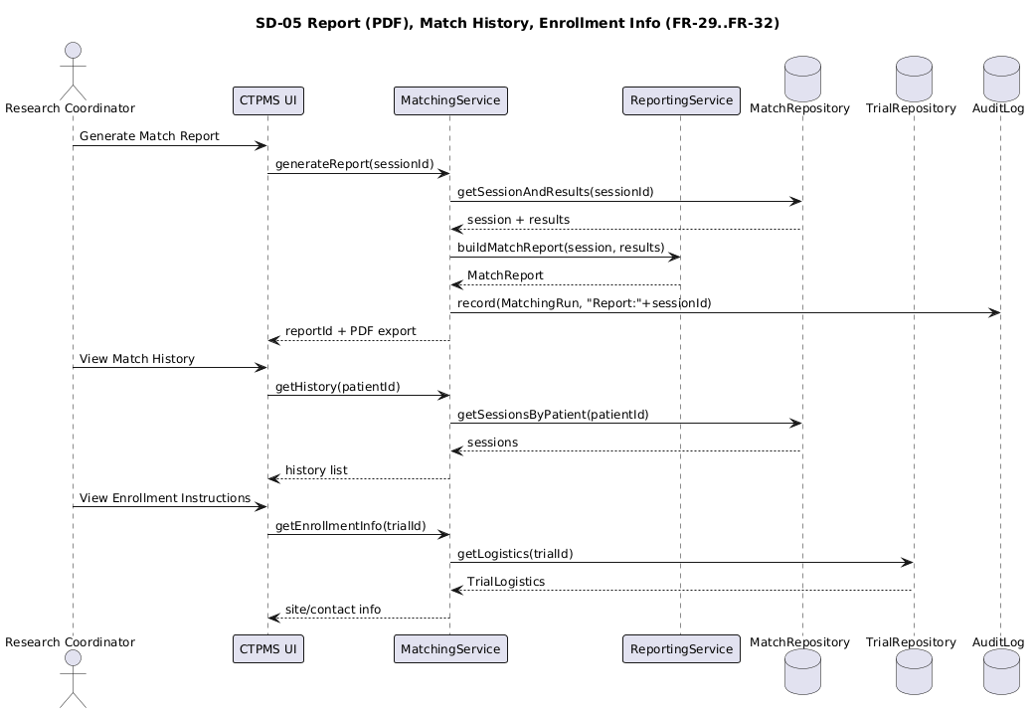

- Screening Workflow, Notifications, Recruitment Report
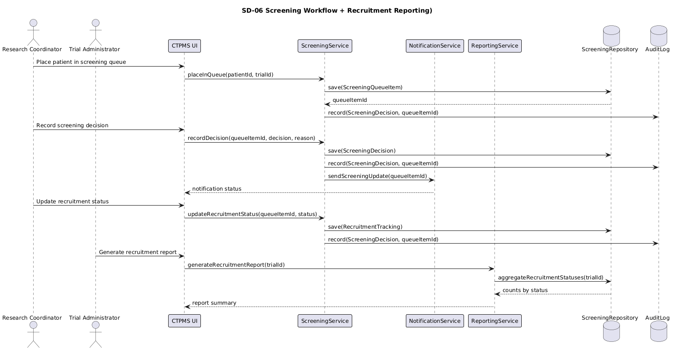

Derivation of Structural and Behavioral Models
The structural and behavioral models of the Clinical Trial Patient Matching System (CTPMS) were derived using a use-case driven object-oriented analysis methodology. Functional requirements (FR-1 through FR-40) were first analyzed to identify domain entities, system responsibilities, and interaction patterns. Structural models were then constructed to represent the static organization of these entities, while behavioral models were developed to validate object collaboration during runtime execution.
This iterative process ensured consistency, separation of concerns, and traceability from functional requirements to system architecture.

Derivation of the Structural Model (Class Diagram)
The class diagram was developed by extracting domain nouns and responsibilities from the functional requirements and use-case descriptions.
Patient Domain (FR-1–FR-9)
Requirements related to patient lifecycle management led to the modeling of the Patient class and its associated clinical data entities, including Diagnosis, Medication, LabResult, BiomarkerResult, TreatmentHistory, and PerformanceStatus. These were modeled using composition relationships to reflect ownership and lifecycle dependency. The inclusion of an isActive attribute supports patient deactivation without data loss.
Trial and Eligibility Domain (FR-10–FR-19)
Trial registration and configuration requirements resulted in the ClinicalTrial class along with TrialLogistics and TrialDiseaseFocus. Eligibility logic was modeled using an abstract EligibilityRule class with specialized InclusionRule and ExclusionRule subclasses. Logical grouping of rules was achieved through the RuleGroup class and LogicalOperator enumeration (AND/OR), ensuring structured and evaluable eligibility criteria.
Matching and Evaluation (FR-20–FR-32)
Matching-related requirements led to the introduction of MatchSession, MatchResult, MatchExplanation, and MatchReport. MatchSession represents a complete execution instance of the matching algorithm, enabling historical tracking. MatchResult captures trial-specific evaluation output, while MatchExplanation provides transparency regarding met, unmet, or unknown criteria. This separation enhances modularity and supports extensibility.
Screening and Recruitment (FR-33–FR-35)
Screening workflow requirements resulted in the modeling of ScreeningQueueItem, ScreeningDecision, and RecruitmentTracking. These classes support controlled progression from eligibility evaluation to enrollment workflow, maintaining structured state transitions and traceable decisions.
Administrative and Audit Controls (FR-36–FR-39)
Role-based access control and system monitoring requirements led to the abstraction of User with specialized roles (ResearchCoordinator, TrialAdministrator, SystemAdministrator). The AuditLogEntry class was included to ensure accountability and action traceability.
Together, these structural elements provide full coverage of FR-1 through FR-40 while maintaining cohesion and minimal coupling across domains.

3. Derivation of the Object Diagram
The object diagram was derived from a representative operational scenario combining matching and screening workflows. It depicts:
- A specific Patient instance with populated clinical data
- An active ClinicalTrial with configured rule groups
- A MatchSession generating categorized results
- A MatchExplanation detailing evaluation reasoning
- A MatchReport generated for review
- A ScreeningQueueItem with associated ScreeningDecision and RecruitmentTracking
- An AuditLogEntry recording system activity
This runtime snapshot validates that the structural relationships defined in the class diagram function cohesively during execution. It demonstrates cross-domain interaction while preserving structural integrity.

4. Derivation of Behavioral Models (Sequence Diagrams)
Behavioral models were developed directly from primary operational use cases. Each major use case was translated into a corresponding sequence diagram to model object collaboration.
- Patient management use cases informed the “Manage Patient & Clinical Data” sequence diagram.
- Trial configuration use cases generated the “Register Trial & Configure Eligibility Rules” sequence diagram.
- Matching requirements produced the “Run Match” sequence diagram, illustrating interactions among matching services, rule evaluation, repositories, and audit logging.
- Screening and reporting requirements informed the workflow and recruitment reporting sequence diagrams.
Each message in the sequence diagrams corresponds to responsibilities defined in the class diagram, ensuring consistency between static structure and dynamic behavior. For example, invocation of runMatch() validates the existence of MatchSession and MatchResult, while screening operations confirm relationships between ScreeningQueueItem, ScreeningDecision, and RecruitmentTracking.

Traceability Between Functional, Structural, and Behavioral Models
Patient Management (FR-1 – FR-9)
- Structural Support:
Patient, Diagnosis, Medication, LabResult, BiomarkerResult, TreatmentHistory, PerformanceStatus
- Behavioral Validation:
Manage Patient & Clinical Data sequence diagram
- Purpose:
Ensures lifecycle control, data integrity, and audit logging of patient records.
Trial Registration & Eligibility Configuration (FR-10 – FR-19)
- Structural Support:
ClinicalTrial, TrialLogistics, TrialDiseaseFocus, RuleGroup, EligibilityRule (Inclusion/Exclusion)
- Behavioral Validation:
Register Trial & Configure Eligibility Rules sequence diagram
- Purpose:
Enables structured rule definition, logical grouping (AND/OR), and trial status management.
Matching, Ranking & Explanation (FR-20 – FR-32)
- Structural Support:
MatchSession, MatchResult, MatchExplanation, MatchReport
- Behavioral Validation:
Run Match, Explanation & Comparison sequence diagrams
- Purpose:
Supports automated evaluation, score ranking, categorization, transparency of criteria evaluation, and report generation.
Screening & Recruitment Workflow (FR-33 – FR-35)
- Structural Support:
ScreeningQueueItem, ScreeningDecision, RecruitmentTracking
- Behavioral Validation:
Screening Workflow & Recruitment Reporting sequence diagram
- Purpose:
Governs post-matching workflow progression and controlled enrollment tracking.
Administrative Control & Audit (FR-36 – FR-39)
- Structural Support:
User (role specialization), RoleType, AuditLogEntry
- Behavioral Validation:
Administrative interaction flows in sequence diagrams
- Purpose:
Enforces role-based access control and ensures full action traceability.
Reporting & Oversight (FR-40)
- Structural Support:
MatchReport, RecruitmentTracking
- Behavioral Validation:
Recruitment Report generation sequence
- Purpose:
Provides operational visibility and decision-support analytics.
Cross-Model Validation
- Every functional requirement is supported by at least one structural entity.
- Every major structural entity participates in at least one behavioral interaction.
- The object diagram demonstrates a runtime scenario confirming that structural relationships support dynamic workflows.
- No use case exists without both structural representation and behavioral validation.

Class-to Use Case Traceability Matrix
CLASS | USE CASE NO | USE CASE NAMES
Patient | UC-1, UC-2, UC-7, UC-8, UC-13 | Manage Patient Profiles; Manage Clinical Data; Run Patient Match; View Match Listings; View Matching History
Diagnosis | UC-2 | Manage Clinical Data
Medication | UC-2 | Manage Clinical Data
LabResult | UC-2 | Manage Clinical Data
BiomarkerResult | UC-2 | Manage Clinical Data
PerformanceStatus | UC-2 | Manage Clinical Data
ClinicalTrial | UC-3, UC-4, UC-5, UC-6, UC-7, UC-11 | Register Clinical Trial; Define Eligibility Rules; Maintain Trial Status & Amendments; Search Clinical Trials; Run Patient Match; Compare Trial Matches
Trial Logistics | UC-3 | Register Clinical Trial
TrialDiseaseFocus | UC-3 | Register Clinical Trial
EligibilityRule | UC-4 | Define Eligibility Rules
RuleGroup | UC-4 | Define Eligibility Rules
MatchSession | UC-7, UC-13 | Run Patient Match; View Matching History
MatchResult | UC-7, UC-8, UC-11 | Run Patient Match; View Match Listings; Compare Trial Matches
MatchExplanation | UC-9 | View Detailed Explanations
MatchReport | UC-12 | Generate Match Reports
ScreeningQueueItem | UC-14 | View Enrollment Instructions
ScreeningDecision | UC-14 | View Enrollment Instructions
RecruitmentTracking | UC-14 | View Enrollment Instructions
User | UC-15 | Manage User Accounts
Role | UC-15 | Manage User Accounts
AuditLogEntry | UC-7, UC-15 | Run Patient Match; Manage User Accounts

